Assignment 4.2
- concat

The concat () function of pig latin is used to concatenate two or more expressions of same type

File name : student_details.txt with fields like

001,Rajiv,Reddy,21,9875627192,Hyderabad,89

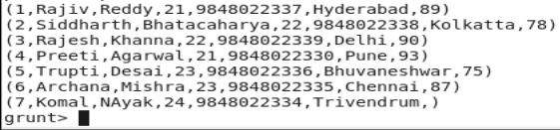

Syntax:
Student_name_concat = foreach student_deatils Generate CONCAT (firstname,lastname);

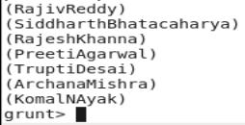

- Tokenize

Tokenize function can be used to split a string. For example, let us split the above student_details.txt using the following command.

Syntax:

student_name_tokenize = foreach student_details Generate TOKENIZE(firstname);

dump student_name_tokenize

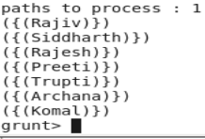

- Sum
We have a file name employee.txt under /home/acadgild/pig. Running dump on employee.txt will give the following output
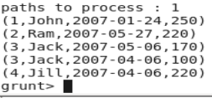
Load Syntax:
employee_data = LOAD '/home/acadgild/pig/employee.txt' USING PigStorage(',') as (id:int, name:chararray, workdate:chararray, daily_typing_pages:int);
Group Syntax:
employee_group = Group employee_data all;
Sum Syntax:
student_workpages_sum = foreach employee_group Generate (employee_data.name,employee_data.daily_typing_pages),SUM(employee_data.daily_typing_pages);

- Min
The min function of pig Latin is used to get the minimum value for a certain column in a single column bag. When calculating the min value NULL is ignored.
Student Details dataset:

Min() Syntax:
student_group_all = Group student_details All;
student_gpa_min = foreach student_group_all Generate
(student_details.firstname, student_details.gpa), MIN(student_details.gpa);

5. Max
The max function of pig Latin is used to get the maximum value for a certain column in a single column bag. When calculating the max value NULL is ignored.
Student Details dataset:

Max() Syntax:
student_group_all = Group student_details All;
student_gpa_max = foreach student_group_all Generate
(student_details.firstname, student_details.gpa), MAX(student_details.gpa);

6. Limit
The limit operator is used to get a limited number of tuples from a relation.
Syntax:
Result = LIMIT Relation_name required number of tuples;
Student Details dataset:
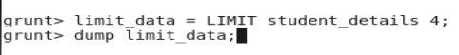

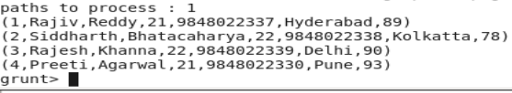

7. Store
We can store the loaded data in the file system using the store operator.
Given below is the syntax of store operator
STORE Relation_name INTO ‘required directory path’ [using function];
Student_details.txt dataset

STORE student_details INTO ' /home/acadgild/new_file ' USING PigStorage (',');

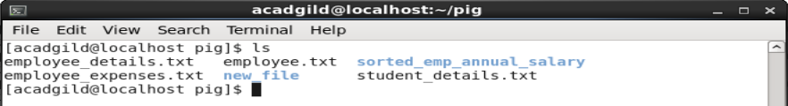

8. Distinct
The distinct operator is used to remove redundant information (duplicate) tuples from a relation.
Syntax:
Relation_name2 = DISTINCT Relatin_name1;
We have a file named student_details
Since there are no duplicate entries in the relation all the rows/entries are displayed.

9. Flatten
The FLATTEN operator looks like a UDF syntactically, but it is an operator that changes the structure of tuples and bags in a way that a UDF cannot. Flatten un-nests tuples as well as bags. The idea is the same, but the operation and result is different for each type of structure

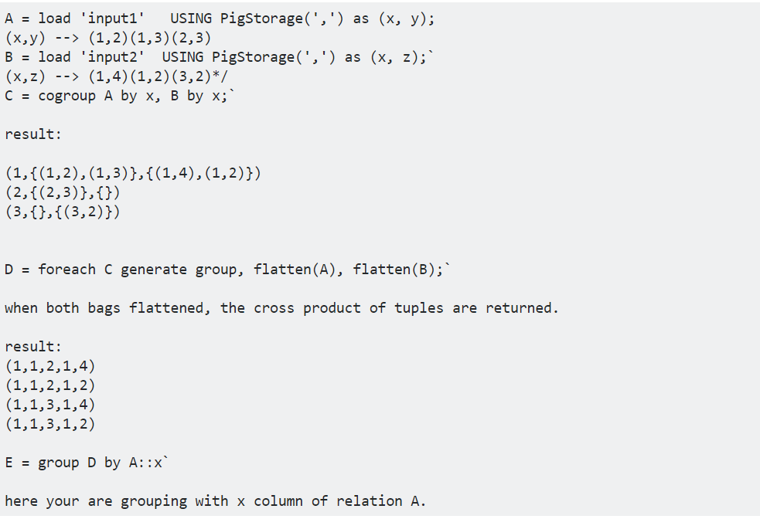

10. IsEmpty
The IsEmpty() function of pig latin is used to check if a bag or map is empty.
Syntax:
IsEmpty(Expression)
Emp_sales.txt
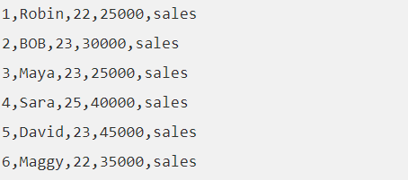
Emp_bonus.txt
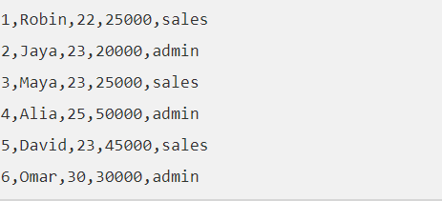

cogroup_data = COGROUP emp_sales by age, emp_bonus by age;
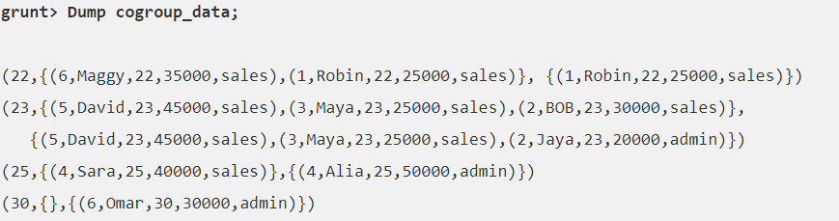

grunt> isempty_data = filter cogroup_data by IsEmpty(emp_sales);
